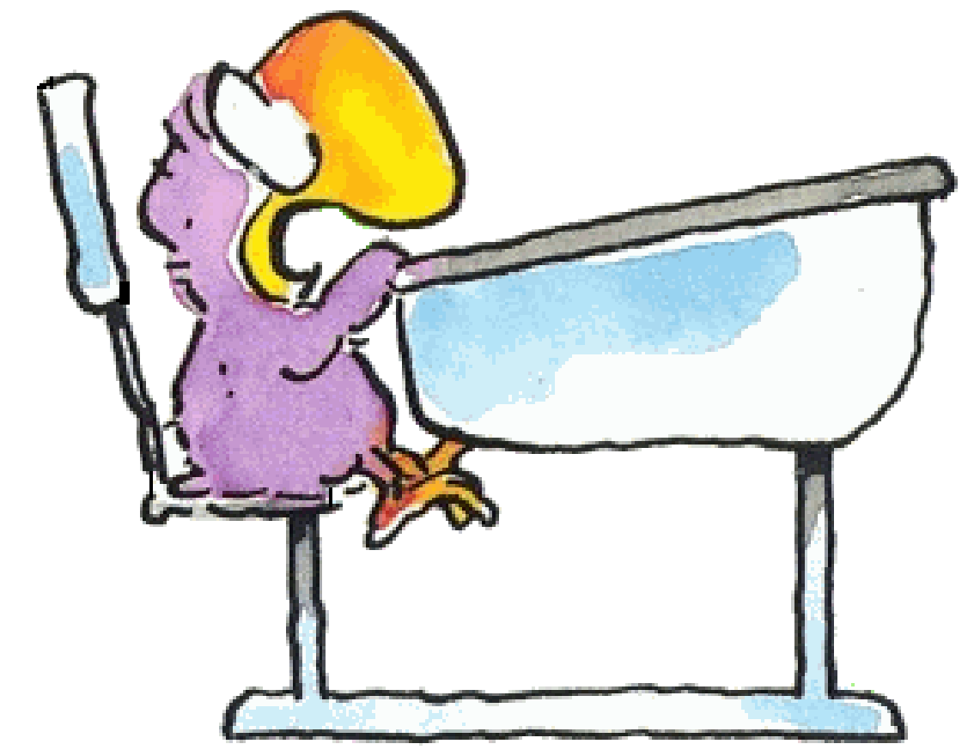
Maaltafel van 2

Ik maak …………………… juiste maaltafels in 1 minuut.

10 x 2 =  8 x 2 =  1 x 2 =  9 x 2=  4 x 2 =  7 x 2 =  5 x 2 =  8 x 2 =  6 x 2 =  0 x 2 =  3 x 2 = | 0 x 2 =  1 x 2 =  6 x 2 =  9 x 2 =  4 x 2 =  2 x 2 =  10 x 2 =  1 x 2 =  8 x 2 =  7 x 2 =  5 x 2 = | 5 x 2 =  7 x 2 =  6 x 2 =  0 x 2 =  4 x 2 =  2 x 2 =  8 x 2 =  1 x 2 =  9 x 2 =  4 x 2 =  3 x 2 =

Zin van de dag:

