Maaltafel van 2 en 10

Ik maak …………………… juiste maaltafels in 1 minuut.

8 x 10 =  6 x 10 =  0 x 10 =  3 x 10 =  5 x 2 =  5 x 10 =  7 x 2 =  6 x 10 =  0 x 2 =  5 x 2 =  10 x 10 =  7 x 10 =  4 x 10 =  2 x 10 =  10 x 2 = | 9 x 10 =  4 x 2 =  2 x 2 =  10 x 10 =  8 x 10 =  2 x 10 =  9 x 10 =  4 x 10 =  7 x 10 =  5 x 10 =  6 x 2 =  10 x 10 =  3 x 2 =  9 x 10 =  0 x 10 = | 10 x 10 =  8 x 2 =  7 x 10 =  2 x 10 =  8 x 2 =  1 x 10 =  9 x 2 =  4 x 10 =  3 x 2 =  0 x 10 =  1 x 10 =  9 x 10 =  2 x 2 =  8 x 10 =  3 x 2 =
Zin van de dag:

Naam: …………………………………………………
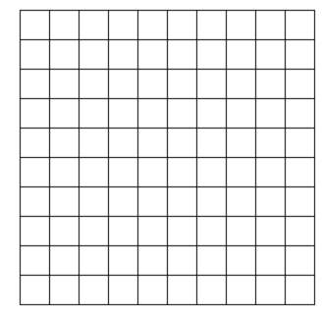

Getal: …………. en …………..

Oefening 1: …………………

Oefening 2: …………………

