Maaltafel van 2,10

Ik maak …………………… juiste maaltafels in 1 minuut.

1 x 2 =  2 x 10 =  3 x 2 =  4 x 2=  5 x 2 =  6 x 10 =  7 x 2 =  8 x 10 =  9 x 2 =  10 x 10 =  0 x 2 =  1 x 10 =  10 x 2 =  10 x 10 =  3 x 2 = | 8 x 10 =  5 x 2=  4 x 10 =  2 x 2 =  1 x 10 =  6 x 10 =  7 x 2 =  9 x 10 =  10 x 10 =  0 x 2 =  3 x 10 =  1 x 10 =  6 x 2 =  2 x 2 =  3 x 10 = | 3 x 2 =  9 x 10 =  7 x 10 =  10 x 10 =  7 x 2 =  8 x 10 =  4 x 2=  5 x 10 =  2 x 10 =  0 x 10 =  6 x 10 =  7 x 2 =  5 x 10 =  2 x 2 =  4 x 2 =
Zin van de dag:

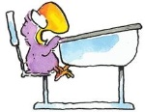
Oefening in de kijker

Welke getallen horen in de vet omrande hokjes?
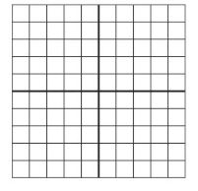

…

Zet 67 op de juiste plaats in het 100-veld.

Los op.
60 : 10 = ..
30 : 10= ..

