Maaltafel van 2,10

Ik maak …………………… juiste maaltafels in 1 minuut.

1 x 10 =  2 x 10=  3 x 10 =  4 x 10 =  5 x 10 =  6 x 10 =  7 x 10 =  8 x 10 =  9 x 10 =  10 x 10 =  0 x 10 =  4 x 10 =  8 x 10 =  0 x 10 =  3 x 10 = | 10 x 10=  7 x 10 =  9 x 10 =  5 x 10 =  4 x 10 =  7 x 10 =  8 x 10=  5 x 10 =  8 x 10 =  3 x 10 =  7 x 10 =  8 x 10 =  6 x 10 =  4 x 10 =  1 x 10= | 2 x 2 =  5 x 10 =  8 x 2 =  10 x 2=  1 x 2 =  0 x 10 =  4 x 2 =  9 x 2 =  6 x 2 =  2 x 10 =  3 x 2 =  9 x 10 =  7 x 2 =  6 x 10 =  4 x 2 =
Zin van de dag:

Oefening in de kijker

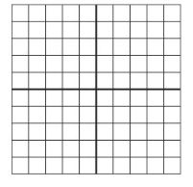
Welke getallen horen in de vet omrande hokjes?

…

…

B
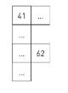
Vul in.

