Maaltafel van 2,10

Ik maak …………………… juiste maaltafels in 1 minuut.

8 x 10 =  5 x 10=  3 x 10 =  2 x 10 =  5 x 10 =  1 x 10 =  7 x 10 =  6 x 10 =  2 x 10 =  1 x 10 =  0 x 10 =  6 x 10 =  3 x 10 =  2 x 10 =  4 x 10 = | 1 x 10=  0 x 10 =  3 x 10 =  2 x 10 =  7 x 10 =  6 x 10 =  5 x 10=  2 x 10 =  1 x 10 =  3 x 10 =  9 x 10 =  10 x 10 =  6 x 10 =  0 x 10 =  10 x 10= | 8 x 2 =  5 x 10 =  7 x 2 =  10 x 2=  6 x 2 =  0 x 10 =  9 x 2 =  3 x 2 =  8 x 2 =  2 x 10 =  7 x 2 =  9 x 10 =  6 x 2 =  1 x 10 =  4 x 2 =
Zin van de dag:

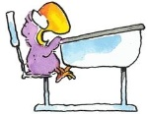
Oefening in de kijker

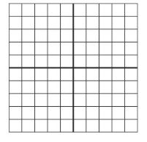
Welke getallen horen in de vet omrande hokjes?

…

…
…

B
Los op.
50 + 10 = …
70 - 20 = …
50 – 30 = …
20 + 60 = …

