*Ik maak …………………… juiste deeltafels in 1 minuut.*

|  |  |  |  |  |
| --- | --- | --- | --- | --- |
| 6 x 8 = | 9 x 8 = | 3 x 5 = | 6 x 8 = | 9 x 8 = |
| 5 x 8 = | 8 x 5 = | 5 x 8 = | 9 x 8 = | 3 x 5 = |
| 7 x 8 = | 6 x 8 = | 5 x 4 = | 7 x 8 = | 6 x 8 = |
| 9 x 5 = | 5 x 8 = | 6 x 8 = | 7 x 4 = | 8 x 8 = |
| 3 x 4 = | 3 x 3 = | 9 x 8 = | 3 x 8 = | 9 x 8 = |
| 3 x 8 = | 5 x 4 = | 4 x 8 = | 10 x 10 = | 3 x 8 = |
| 7 x 8 = | 4 x 8 = | 7 x 8 = | 7 x 8 = | 6 x 8 = |
| 6 x 8 = | 7 x 3 = | 9 x 5 = | 2 x 8 = | 7 x 8 = |
| 5 x 8 = | 10 x 8 = | 9 x 3 = | 3 x 8 = | 9 x 5 = |
| 6 x 8 = | 9 x 8 = | 0 x 8 = | 1 x 8 = | 8 x 8 = |
| 4 x 5 = | 9 x 4 = | 9 x 2 = | 6 x 8 = | 7 x 8 = |
| 3 x 5 = | 5 x 3 = | 8 x 8 = | 9 x 8 = | 1 x 8 = |

*Ik maak …………………… juiste maaltafels in 1 minuut.*

**De maal- en deeltafeltoets**

|  |  |  |  |  |
| --- | --- | --- | --- | --- |
| 64 : 8 = | 27 : 3 = | 30 : 5 = | 35 : 5 = | 45 : 5 = |
| 36 : 4 = | 32 : 4 = | 56 : 8 = | 28 : 4 = | 20 :10 = |
| 56 : 8 = | 60 : 10 = | 24 : 4 = | 9 : 3 = | 56 : 8 = |
| 72 : 8 = | 21 : 3 = | 12 : 3 = | 27 : 3 = | 21 : 3 = |
| 3 : 3 = | 36 : 4= | 27 : 3 = | 48 : 8 = | 15 : 3 = |
| 12 : 3 = | 15 : 3 = | 18 : 3 = | 40 : 8 = | 18 : 3 = |
| 40 : 4 = | 12 : 3 = | 32 : 8 = | 16 : 8 = | 24 : 8 = |
| 32 : 4 = | 48 : 8 = | 35 : 5 = | 8 : 8 = | 30 : 5 = |
| 72 : 8 = | 15 : 3 = | 24 : 4 = | 24 : 24 = | 24 : 3 = |
| 25 : 5 = | 25 : 5 = | 24 : 8 = | 15 : 15 = | 45 : 5 = |
| 56 : 8 = | 60 : 10 = | 24 : 4 = | 9 : 3 = | 40 : 8 = |
| 6 : 1 = | 32 : 8 = | 30 : 3 = | 2 : 1 = | 21 : 3 = |



Zin van de dag:

**Naam: …………………………………………………………………………**



|  |
| --- |
| Oefening in de kijker |



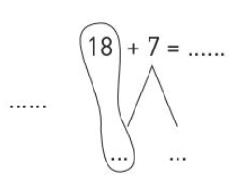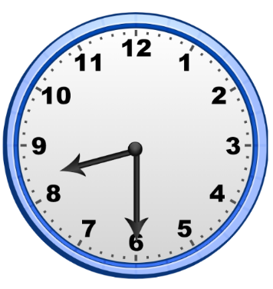**Los op Hoe laat is het?**



